Assignment – 1

• Install Power BI Desktop and share the final screenshot of the report view page which appears when power desktop starts.

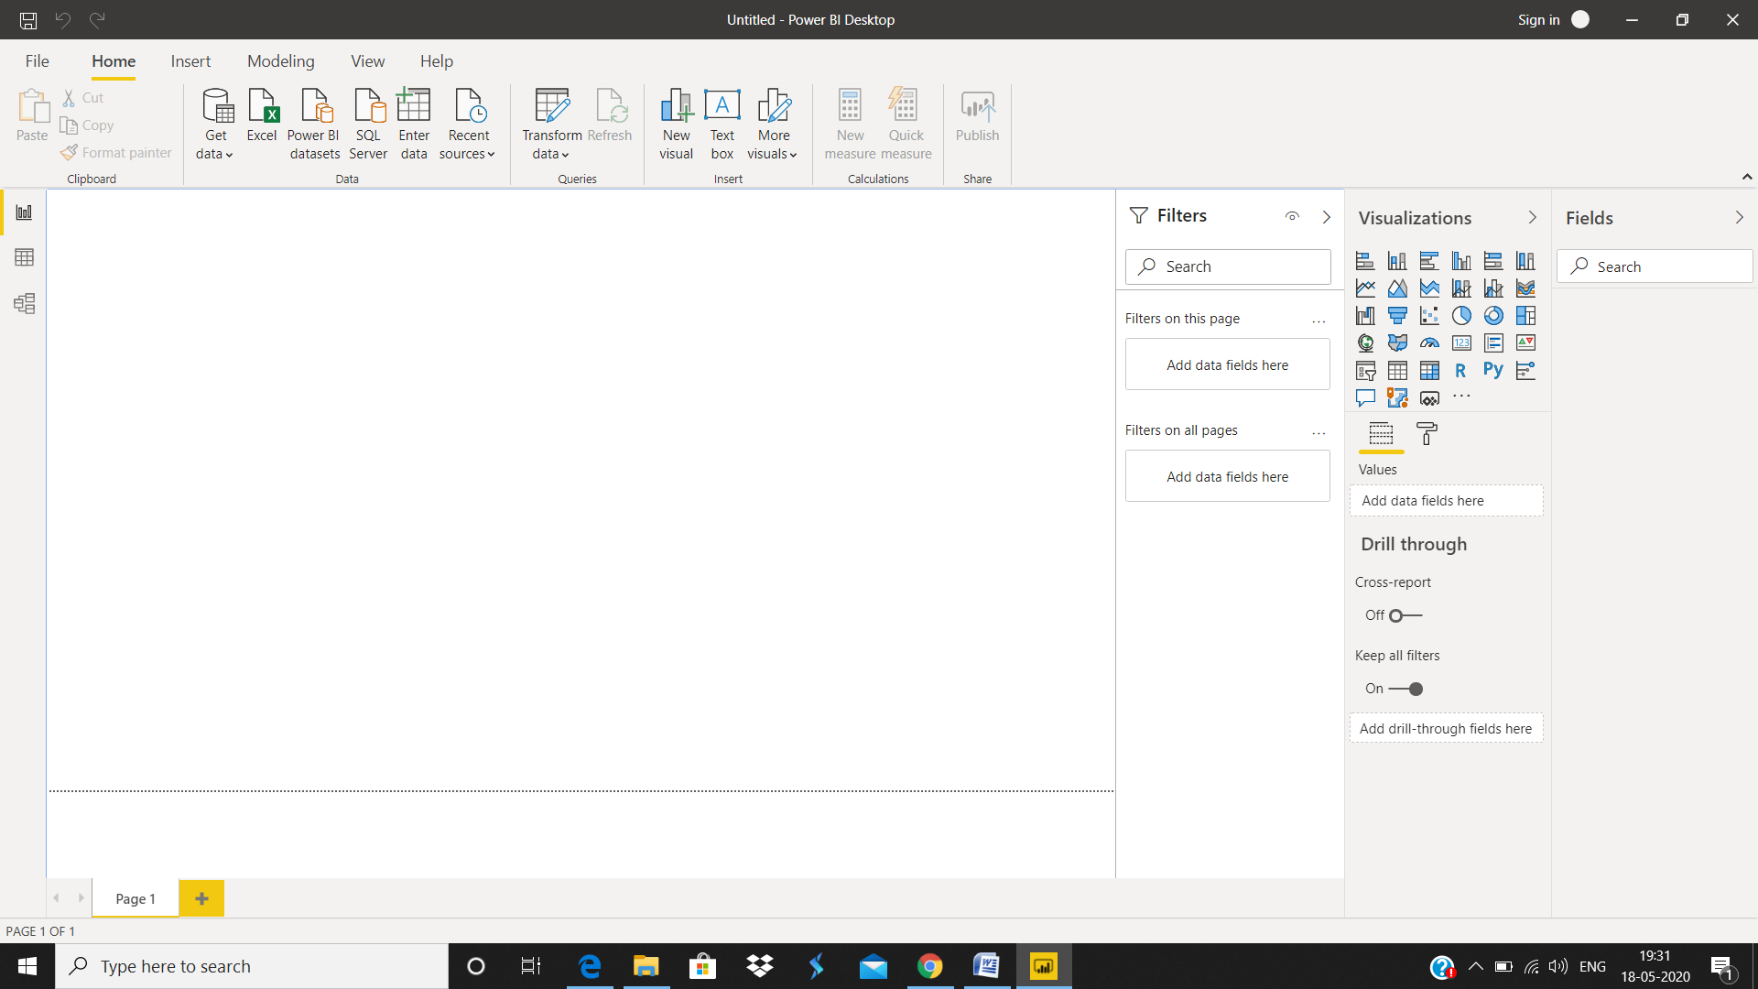

• Prepare a document and with the following screenshot

**Report** view – where you use queries you create to build compelling visualizations, arranged as you want them to appear, and with multiple pages, that you can share with others

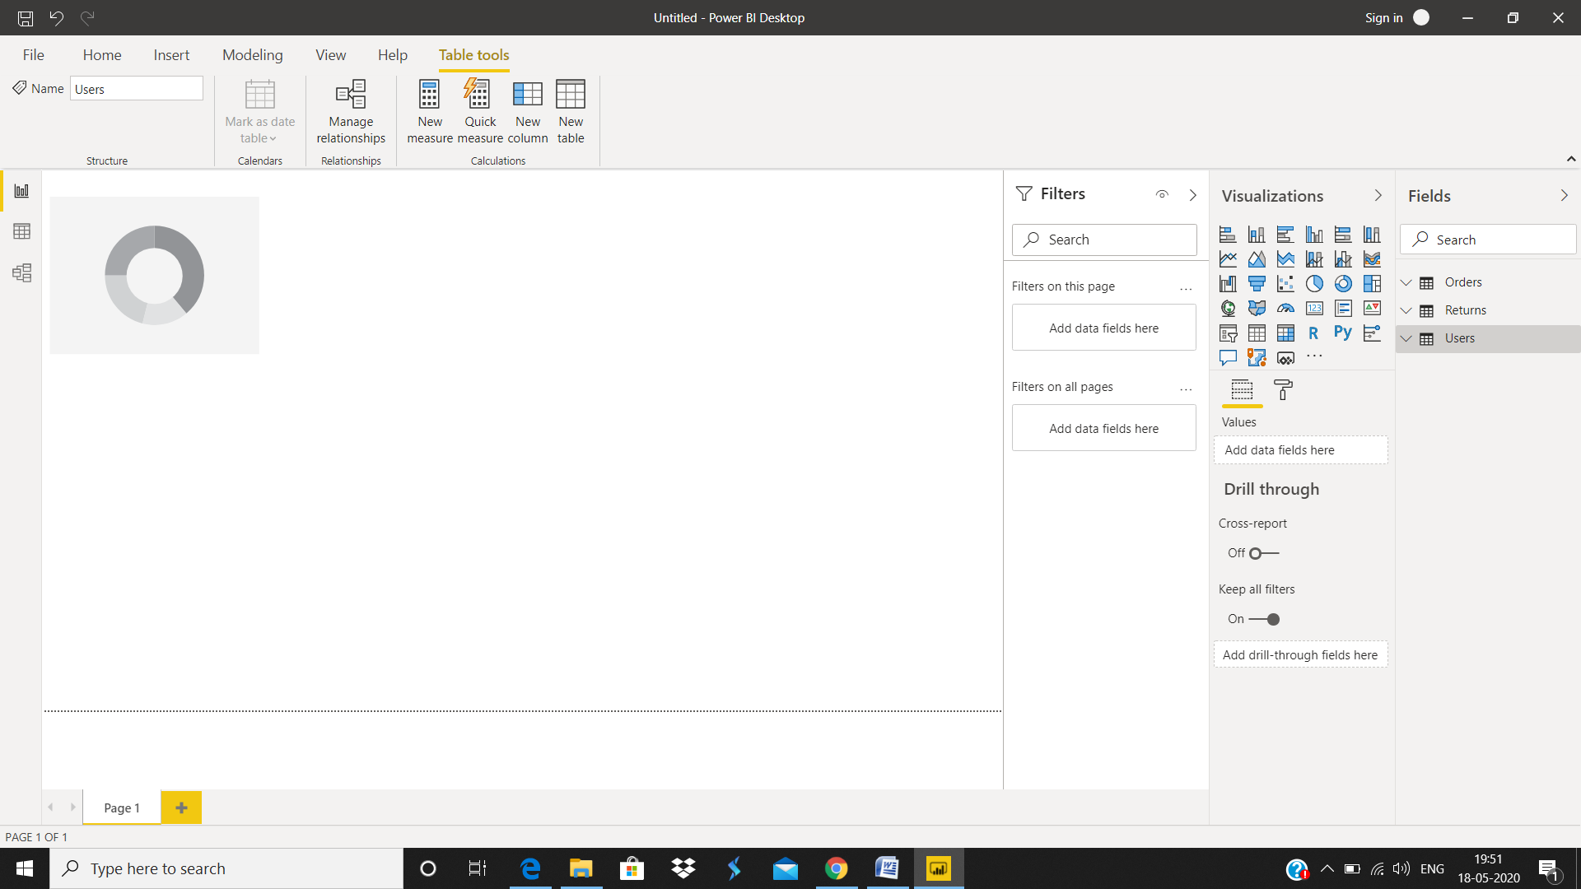

* **Data** view – see the data in your report in data model format, where you can add measures, create new columns, and manage relationships

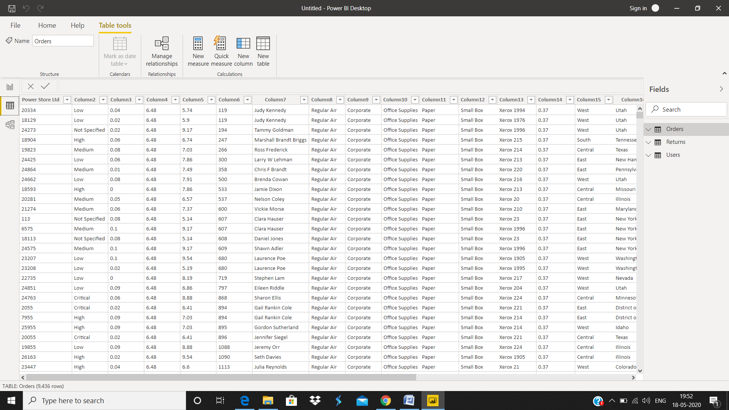

* Model View– get a graphical representation of the relationships that have been established in your data model, and manage or modify them as needed.

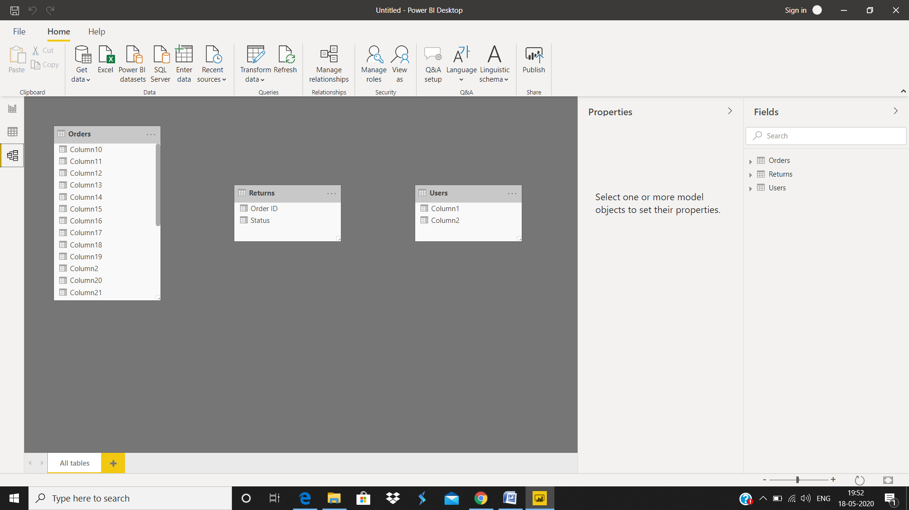

* Power Query Editor

To get to Power Query Editor, select **Edit Queries** from the **Home** tab of Power BI Desktop.

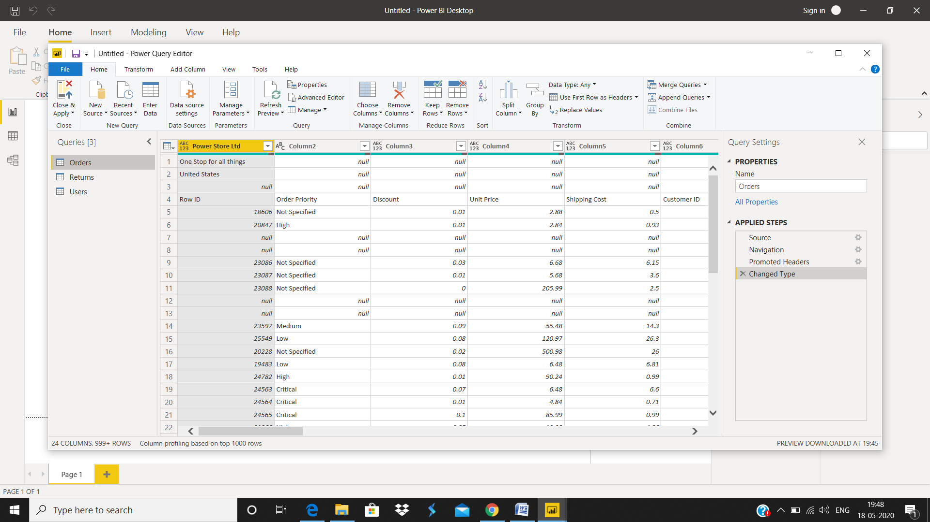

* Advance Editor

The **Advanced Editor** lets you see the code that Power Query Editor is creating with each step. It also lets you create your own shaping code. To launch the advanced editor, select **View** from the ribbon, then select **Advanced Editor**. A window appears, showing the existing query code.

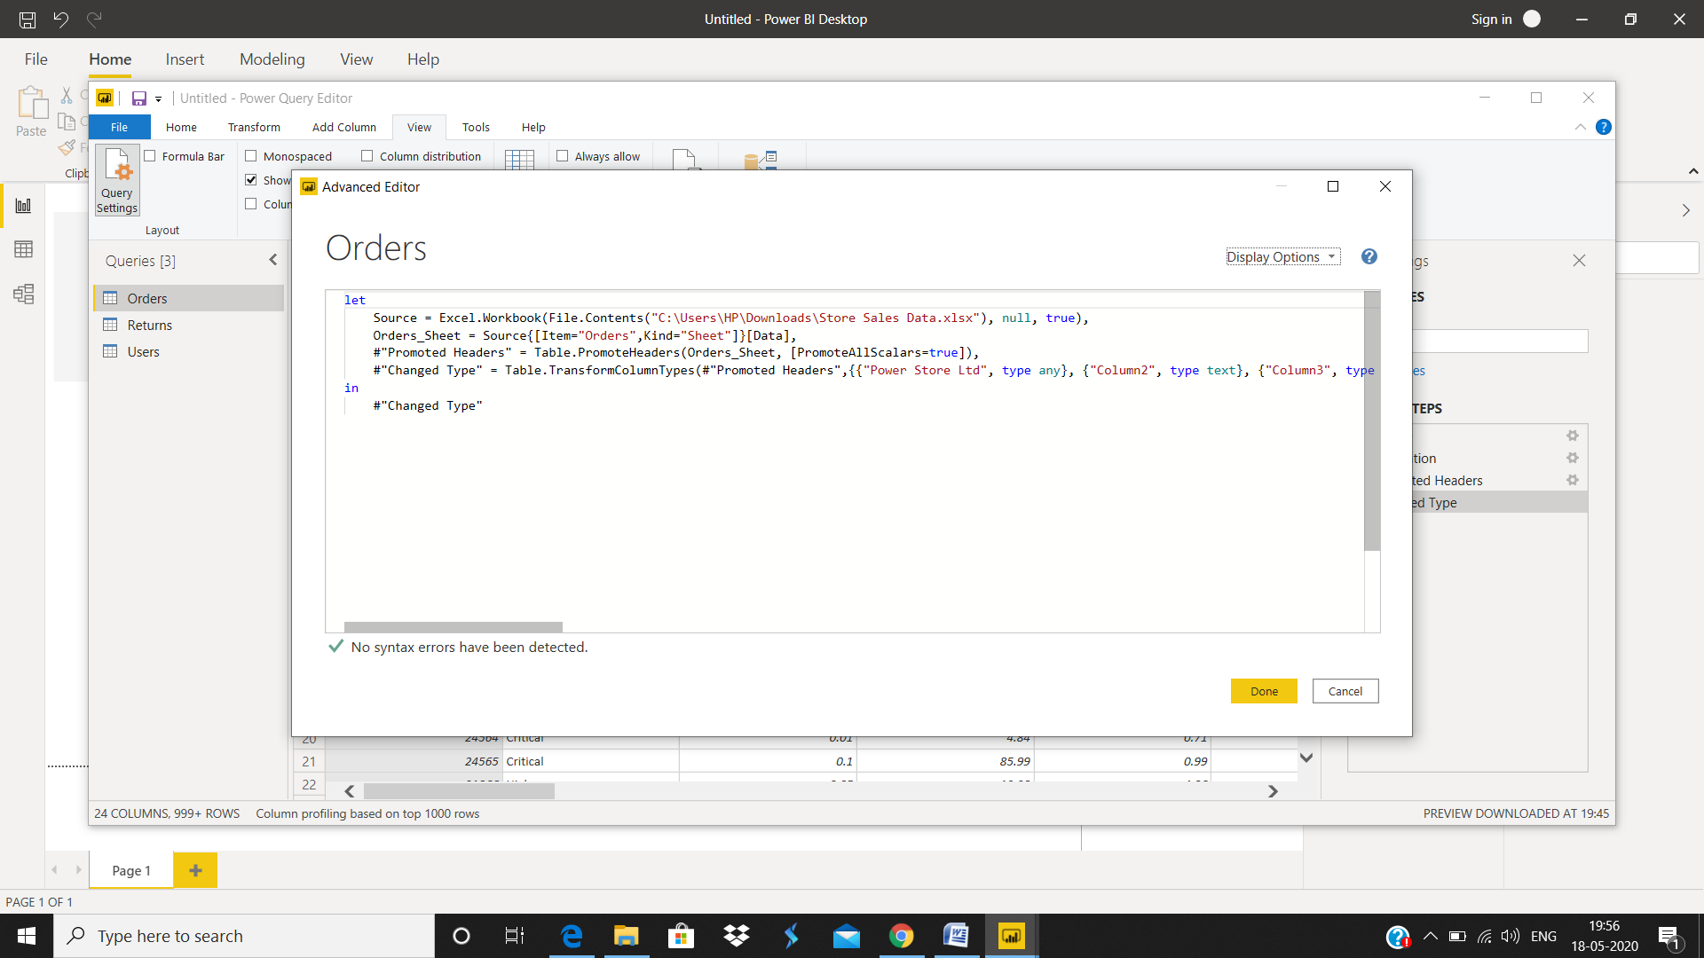

Prepare a document with details of the following along with their price

− Power BI Desktop

− Power BI Pro

− Power BI Premium

Power BI Desktop

*Power BI Desktop* is a free application you install on your local computer that lets you connect to, transform, and visualize your data. With Power BI Desktop, you can connect to multiple different sources of data, and combine them (often called *modeling*) into a data model. This data model lets you build visuals, and collections of visuals you can share as reports, with other people inside your organization. Most users who work on business intelligence projects use Power BI Desktop to create reports, and then use the *Power BI service* to share their reports with others.

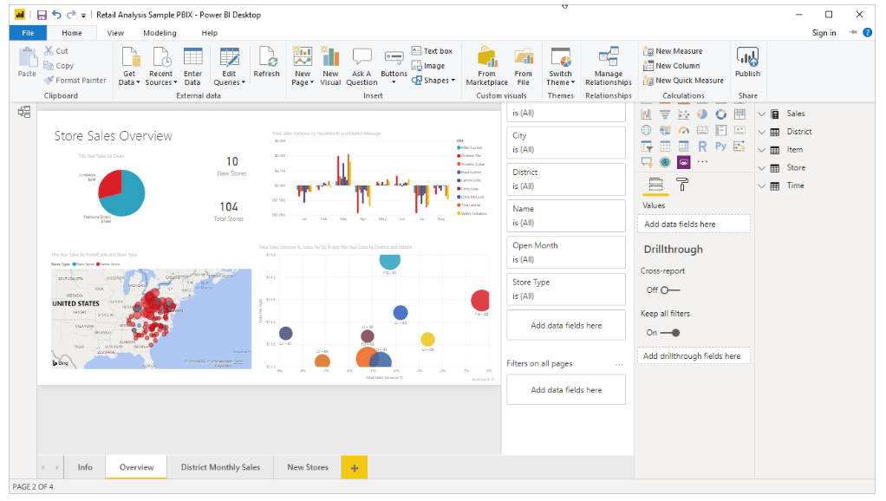

**Power BI Pro Cost**

The Pro plan costs $9.99/user/month. It includes data collaboration, data governance, building dashboards with a 360-degree real-time view and the ability to publish reports anywhere. Users can try it a free trial for 60 days before purchasing the subscription.

**How to get Power BI Pro License?**

In order to get the Power BI Pro license, follow the steps below:

1. Open the Microsoft 365 admin centre.
2. On the left navigation pane, select Billing > Subscriptions.
3. In the upper right corner of the Subscriptions page, select Add subscriptions.
4. Locate the desired subscription offering:
5. Under Enterprise Suite, select Office 365 Enterprise E5.
6. Office E5 subscription
7. Under Other Plans, select Power BI Pro.
8. Hover over the ellipsis (. . .) for the desired subscription, and select Buy now.
9. Choose Pay monthly or Pay for a full year, according to your billing preference.
10. Under How many users do you want? enter the desired number of licenses, and then select “Check out now” to complete the transaction.
11. Verify that the acquired subscription is now listed on the Subscriptions page.
12. Acquired subscription
13. To add more licenses after the initial purchase, select Power BI Pro from the Subscriptions page, and then select Add/Remove licenses.

**What is Power BI Premium?**

The Power BI Premium licence is not a per-user licence like a Free or Pro Licence. Instead, Power BI Premium licence provides a dedicated unit of capacity for all users in the organisation. This dedicated capacity (aka Premium Workspace) can be used to host large datasets up to 50GB while offering a total storage of 100TB in the cloud.

It enables your organization to use your own dedicated capacity and hardware rather than relying on Microsoft’s shared capacity. Although you will in fact need to determine said capacity accurately and ensure that it has the capabilities to handle your reporting and analysis needs. This allows for much larger scale and better performance if you size the capacity properly. Microsoft offers three sizes for Premium capacity and each come with a different number of v-cores and memory size.

**Who is Power BI Premium for?**

Power BI Premium is for use in large organisations with a great number of users that need to collaborate in real time. The application is geared towards addressing the challenges of large enterprise deployments and workloads.

**Power BI Premium Cost**

The Premium plan starts at $4,995 a month per dedicated cloud compute and storage resource. This does not include the cost of licensing for individual Pro and Free licenses required for each user in your organisation.

**How to get Power BI Premium?**

Power BI Premium is a tenant-level Office 365 subscription available in two SKU (Stock-Keeping Unit) families:

1. EM SKUs (EM1-EM3) for embedding, requiring a yearly commitment, billed monthly.
2. P SKUs (P1-P3) for embedding and enterprise features, requiring a monthly or yearly commitment, billed monthly, and includes a license to install Power BI Report Server on-premises.

Furthermore, Power BI Premium subscriptions can be purchased by administrators in the Microsoft 365 admin centre. To be more specific, only Office 365 Global administrators or Billing Administrators can actually make purchases as they have designated authority. Once the capacity has been purchased, you will receive the corresponding number of v-cores to assigned to the capacity you have chosen, known as v-core pooling. For example, purchasing a P3 SKU provides the tenant with 32 v-cores for data processing etc.

**What is Power BI App? Is Power BI available on Mobile?**

By default, all of Power BI’s version (Desktop, Pro and Premium) can be connected via mobile applications. To get the app you simply have to download and install the Power BI Desktop app from the Microsoft Store. The app offers a number of added benefits such as automatic updates. Although you can’t, however, operate Power BI Pro and Free apps simultaneously.

Furthermore, native smartphone and tablet Power BI Mobile applications are available for multiple platforms including Android, iOS and Windows devices. These apps act as a complimentary service aimed at enabling report viewing when on the move or away from your primary computer.

**What is Power BI Report Server?**

Power BI Report Server is an on-premises (at your own location) server that lets you and your business build your BI initiatives on local hardware, and publish and share both Power BI reports and traditional reports created with SQL Server Reporting Services from within your organisation’s firewall. In simpler terms, the server you use for managing your collaboration through Power BI will be at your location using infrastructure that is physically present.

**Is Power BI On Premise available?**

Power BI On Premise or Report Server is an option included with Power BI Premium and is ideal for your business if you want to establish reporting infrastructure on-premises and have it operate under your own policies and rules. Furthermore, the server will allow you to seamlessly scale up and move to the cloud should you ever wish to do so. Power BI Report Server also lets you use the same number of virtual cores provisioned in the cloud on-premises, without the need to split capacity. Lastly, if you would like Power BI Report Server but don’t want to take the plunge just yet and don’t want to buy Power BI Premium, the Power BI Report Server is also available as part of the SQL Server Enterprise Edition – but only if you have active Software Assurance.

**Power BI Pro vs. Power BI Premium vs. Power BI Free key differences explained**

The key difference between Power BI Pro vs. Free version vs. Power BI Premium is in the core functionality and data processing / handling capacity. That is to say there is a difference of handling capacity in Power BI Pro vs. Free. On the other hand, there is a difference in data capacity in Power BI Pro vs. Premium. Furthermore, in terms of report generation in Power BI Pro vs. Free version, the former gives more options and improves collaboration quality.

By having a Premium license, your smaller number of Pro users unlock more capacity (larger storage sizes) and higher limits (refresh rates, isolation, etc.) therefore, it’s not really a case of only having one or the other.

**Limitations: Power BI Free Vs Power BI Pro Vs Power BI Premium**

**Power BI Free**

Naturally, there are some feature limitations with Power BI Desktop which in many cases are an incentive to upgrade:

* Can’t share created reports with non-Power BI Pro users
* No App Workspaces
* No API embedding
* No email subscriptions
* No peer-to-peer-sharing
* No support to analyse in Excel within Power BI Desktop

Although, all things considered, there is a problem with secure sharing in the latter in case of Power BI Pro vs. Free. If you publish a report to the Web, it is made public, and anyone on the internet can potentially search and find the data. In this case Power BI Pro users have the advantage of sharing reports directly with other Pro users besides of course uploading the document to a Premium workspace.

**Power BI Premium**

Power BI Premium is not a standalone application in that it has to work with Power BI Pro in tandem. You cannot operate the first without a large number of the latter. The reason for this is simple: Power BI Premium only lets your users consume (view) Power BI content rather than actually create reports.

It’s important to understand that even with a Power BI Premium license, your organisation’s members that are generating reports as well as those that are simply viewing them (Power BI Pro vs. Free) will still require their own Power BI licenses in order to create reports for consumption for the rest of your users (those just viewing) covered by Premium.

**Advantages: Power BI Free Vs Power BI Pro Vs Power BI Premium**

Despite its free nature, you may be surprised at what Microsoft has included with Power BI Desktop:

* You can connect and import data from over 70 cloud-based and on-premises sources
* The same rich visualisations and filters from Power BI Pro
* Auto-detect that finds and creates data relationships between tables and formats
* Export your reports to CSV, Microsoft Excel, Microsoft PowerPoint and PDF
* Python support
* Save, upload and publish your reports to the Web and the full Power BI service
* Storage limit of 10 GB per user

**Power BI Pro**

On the other hand, in the case of Power BI Pro vs. Free, you have:

* Ability to embed Power BI visuals into apps (PowerApps, SharePoint, Teams, etc)
* Native integration with other Microsoft solutions (Azure Data Services)
* Share datasets, dashboards and reports with other Power BI Pro users
* Can create App Workspaces and peer-to-peer sharing
* To securely share a Report, a Pro user can share with another Pro user, or place the Report on a Premium Workspace and share it with Free licence users.

**Power BI Premium**

Mainly, the advantage garnered through using Power BI Premium is the dedicated capacity and the ease of access for those that need to consume the data / reports.

**How do you know the best Power BI license/version for your business?**

The choice between only having either Power BI Pro and Power BI Premium and whether you need to run them together boils down to your assessment of your organisations size and consumption needs i.e. how many need to create reports, how many need to review / access those reports and how many simply need a dashboard / at-a-glance style of reporting. This is because if you’re a large company with more users that need to consume your reports than create them, Power BI Premium is the optimal choice, and you can purchase a lesser amount of Pro licenses for your self-service team.

However, in the case that you have more self-service BI users that need to be able to create reports than those who actually need to view them, Power BI Pro’s individual licensing model on its own may be more cost-effective BI option. In this case you simply need to share directly the reports you make with those that need to view them.

A good way to explain the above scenarios is through a business case example used by Microsoft to help illustrate Power BI Pro vs. Premium suitability:

* If an organisation consists of 200 total users – 50 are engaging in self-service BI, while the remaining 150 are limited to viewing BI content
  1. Deployment Power BI Pro is an economical option for all users within the organisation.
* However, if the organisation consists of 700 total users – 100 are engaging in self-service BI, while the remaining 600 occasionally view BI content
  1. Deploy Power BI Pro for the 100 users engaging in self-service BI
  2. Deploy Power BI Premium for the 600 seeking occasional access to view BI content.
* If the organisation instead consists of 5,000 total users – 4,000 are engaging in self-service BI, while the remaining 1,000 occasionally view BI content
  1. Deploy Power BI Pro for the 4,000 users engaging in self-service BI
  2. Deploy Power BI Premium for the 1,000 seeking occasional access to view BI content.